**ASSIGNMENT -1**

Q1) How to input two numbers and display the sum of two numbers?

Q2) Create a simple HTML form and accept the user name and display the name through PHP echo statement.

*Sample output of the HTML form :*

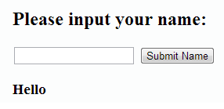

Q3) Write a function to check whether a number is prime or not

Q4) Write a function to reverse a string.

Q5)Write a simple login page using PHP with MYSQL Database.

Q6)How do you create a cookie in PHP?

Q7) **What are the differences between echo and print?**

Q8)**How can you declare the array in PHP?**